TABLE AND FORM DESIGN

SUBMITTED BY,

**RESHMA R**

ROLL NO: 44

S5 LE MCA

**1.tbl_user**

Primar Key **:** usertype

Description : To identify the type of the user.

|  |  |  |  |
| --- | --- | --- | --- |
| **SL NO** | **FIELD** | **DATATYPE** | **DESCRIPTION** |
| 1 | usertype_id | Int | User type id |
| 2 | usertype | Varchar(15) | User type |
| 3 | status | Varchar(15) | Status |

1. **tbl_login**

Primary Key **:** uid

Foreign Key **:** usertype

Description **:** To store login details

|  |  |  |  |
| --- | --- | --- | --- |
| **SL NO** | **FIELD** | **DATA YPE** | **DESCRIPTION** |
| 1 | usertype | Varchar(15) | User type |
| 2 | uid | Int | User id |
| 3 | uname | Varchar(25) | User name |
| 4 | pwd | Varchar(25) | Password |
| 5 | status | Varchar(25) | Status |

1. **tbl_matereg**

Primary key : reg_id

Description : To store registration details of the mate

|  |  |  |  |
| --- | --- | --- | --- |
| **SL NO** | **FIELD** | **DATA TYPE** | **DESCRIPTION** |
| 1 | reg_id | Int | Registration id |
| 2 | name | Varchar(35) | Name |
| 3 | dob | Date | Date of birth |
| 4 | address | Varchar(50) | Address |
| 5 | specific | Varchar(30) | Specification |

1. **tbl_village**

Primary Key **:** vid

Description **:** To store village details

|  |  |  |  |
| --- | --- | --- | --- |
| **SL NO** | **FIELD** | **DATA TYPE** | **DESCRIPTION** |
| 1 | vid | Int | Village id |
| 2 | vname | Varchar(20) | Village name |
| 3 | status | Varchar(20) | Status |

1. **tbl_jobcard**

Primary Key **:** jid

Description **:** To store employee details for job card

|  |  |  |  |
| --- | --- | --- | --- |
| **SL NO** | **FIELD** | **DATA TYPE** | **DESCRIPTION** |
| 1 | jid | Varchar(20) | Job card id |
| 2 | name | Varchar(30) | Name |
| 3 | dob | Date | Date of birth |
| 4 | sex | Varchar(10) | Sex |
| 5 | address | Varchar(50) | Address |
| 6 | ward | Int | Ward |
| 7 | date | Date | Date |
| 8 | adno | Int | Aadhar card number |
| 9 | rationno | Int | Ration card number |
| 10 | acno | Int | Account number |
| 11 | ifsc | Varchar(15) | IFSC code |
| 12 | photo | Varchar(100) | Photo |
| 13 | hno | Varchar(15) | House number |
| 14 | category | Varchar(30) | Category |
| 15 | fhname | Varchar(30) | Father/Husband name |
| 16 | status | Varchar | Status |

1. **tbl_state**

Primary Key **:** sid

Description **:** To store state details

|  |  |  |  |
| --- | --- | --- | --- |
| **SL NO** | **FIELD** | **DATA TYPE** | **DESCRIPTION** |
| 1 | sid | Int | State id |
| 2 | sname | Varchar(30) | State name |
| 3 | status | Varchar(15) | Status |

1. **tbl_job**

Primary Key **:** rid

Foreign Key **:** jid

Description **:** To store job details

|  |  |  |  |
| --- | --- | --- | --- |
| **SL NO** | **FIELD** | **DATA TYPE** | **DESCRIPTION** |
| 1 | jid | Varchar(15) | Job card id |
| 2 | rid | Varchar(10) | Request id |
| 3 | jname | Varhar(20) | Job name |
| 4 | jplace | Varchar(25) | Job place |
| 5 | date | Date | Date |
| 6 | description | Varchar(25) | Description |
| 7 | ndays | Int | Number of days |
| 8 | Status | Varchar(25) | Status |

1. **tbl_jobschedule**

Primary Key **:** schedid

Description **:** To store job schedule details

|  |  |  |  |
| --- | --- | --- | --- |
| **SL NO** | **FIELD** | **DATA TYPE** | **DESCRIPTION** |
| 1 | schedid | Varchar(25) | Schedule id |
| 2 | date | Date | Date |
| 3 | place | Varchar(25) | Place |
| 4 | description | Varchar(25) | Description |
| 5 | nda**y**s | Int | Number of days |
| 6 | deadline | Varchar(25) | Deadline |
| 7 | status | Varchar(25) | Status |

1. **tabl_attendence**

Primary Key **:** aid

Foreign Key **:** jid

Description **:** To store attendence details

|  |  |  |  |
| --- | --- | --- | --- |
| **SL NO** | **FIELD** | **DATA TYPE** | **DESCRIPTION** |
| 1 | Aid | Int | Attendance id |
| 2 | Jid | Varchar(15) | Job card id |
| 3 | Date | Date | Date |
| 4 | Attendance | Varchar(15) | Attendance |
| 5 | Ndays | Varchar(20) | Number of days |
| 6 | Wages | Int | Wages |

1. **tbl_notification**

Primary Key **:** nid

Foreign Key **:** usert**y**pe

Description **:** To store notification details

|  |  |  |  |
| --- | --- | --- | --- |
| **SL NO** | **FIELD** | **DATA TYPE** | **DESCRIPTION** |
| 1 | nid | Int | Notification id |
| 2 | usert**y**pe | Varchar(15) | User type |
| 3 | notification | Varchar(50) | Notification |
| 4 | status | Varchar(20) | Status |

1. **tbl_complaints**

Primary Key **:** cid

Foreign Key **:** jid

Description **:** To store complaints details

|  |  |  |  |
| --- | --- | --- | --- |
| **SL NO** | **FIELD** | **DATA TYPE** | **DESCRIPTION** |
| 1 | cid | Int | Complaint id |
| 2 | jid | Varchar(15) | Job card id |
| 3 | complaints | Varchar(50) | Complaints |
| 4 | status | Varchar(20) | Status |
| 5 | replay | Varchar(50) | Repla**y** |

**12. tbl_feedback**

Primary Key **:** fid

Foreign Key **:** jid

Description **:** To store feedback details

|  |  |  |  |
| --- | --- | --- | --- |
| **SL NO** | **FIELD** | **DATA TYPE** | **DESCRIPTION** |
| 1 | fid | Int | Feedback id |
| 2 | jid | Varchar(15) | Job card id |
| 3 | feedbacks | Varchar(50) | Feedbacks |
| 4 | status | Varchar(20) | Status |
| 5 | replay | Varchar(50) | Repla**y** |

FORM DESIGN

1. LOGIN FORM

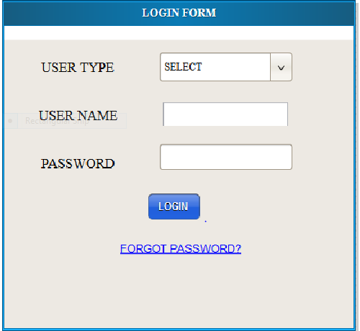

1. USER HOME

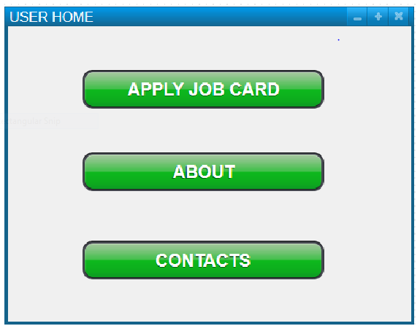

1. APPLY JOB CARD

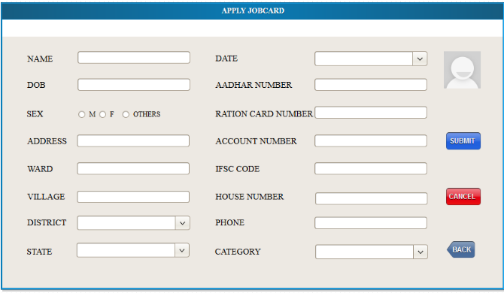

1. ADMIN HOME

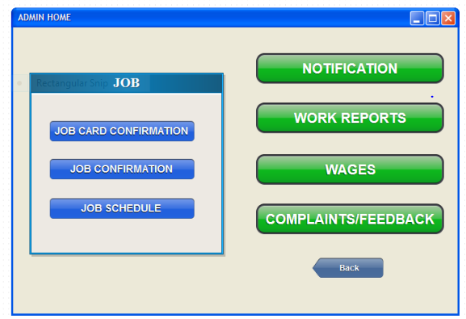

1. MATE REGISTRATION

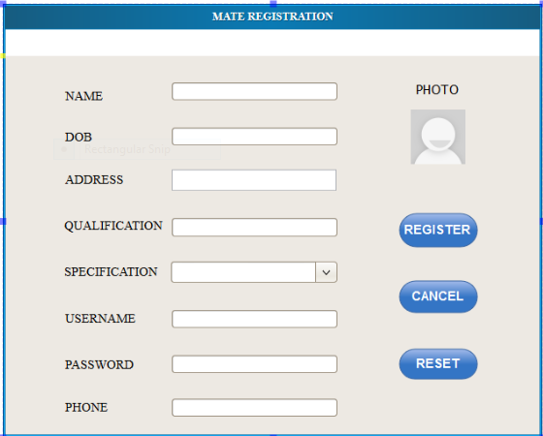

1. EMPLOYEE HOME

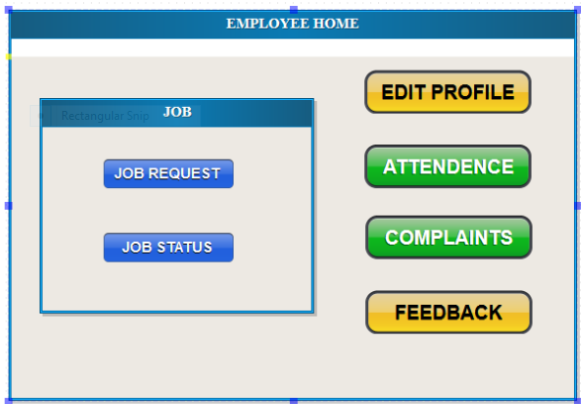

1. JOB REQUEST

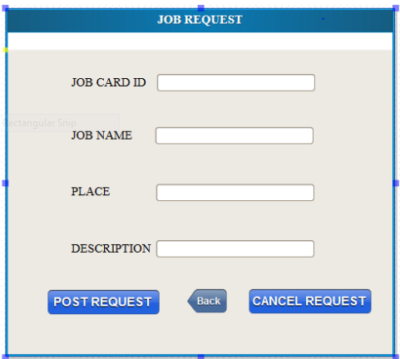

1. JOB SCHEDULE

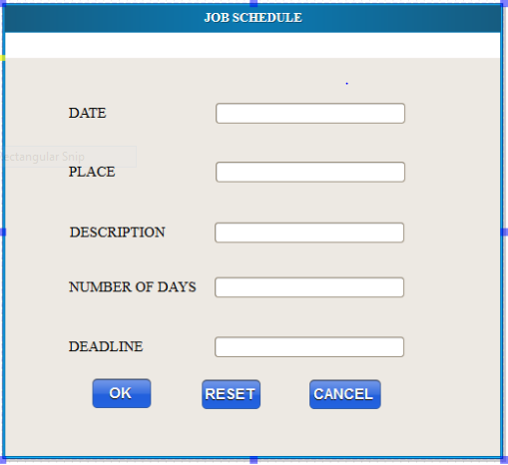

1. NOTIFICATION

